Boyertown Spaatz Memorials

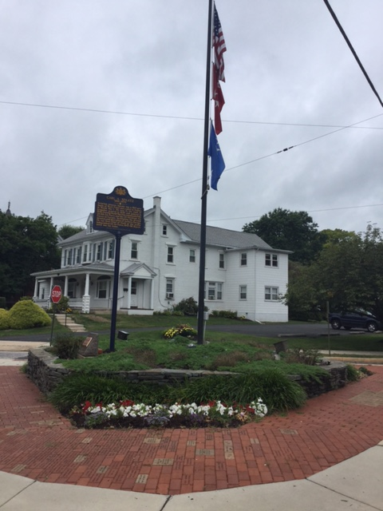
The Spaatz Memorial at the corner of 2nd Street and route 562 (now the General Carl A. Spaatz Memorial Highway) was dedicated in 1986 by the Spaatz Memorial Association and is maintained with help from the Boyertown Rotary. Commemorative bricks celebrate Boyertown veterans and their loved ones as well as military supporters. Note the two four star flags. General Spaatz was the only US general to hold four star rank in two services. Though often confused with General Spaatz parents’ 2nd house “The Knoll”, the white house in the photo background is a private residence not associated with the Spatz family.

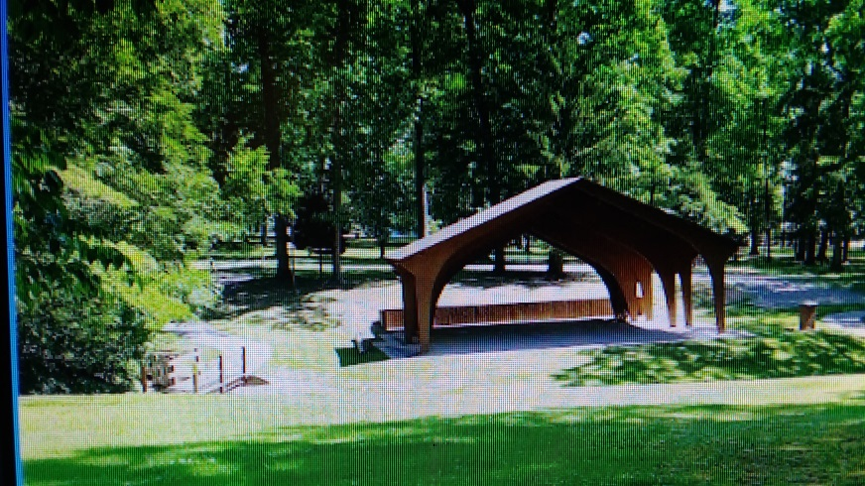
The Spaatz Pavilion located in the Boyertown community park was rededicated in 2015 unveiling a marker commemorating the late Generals birthplace of Boyertown.

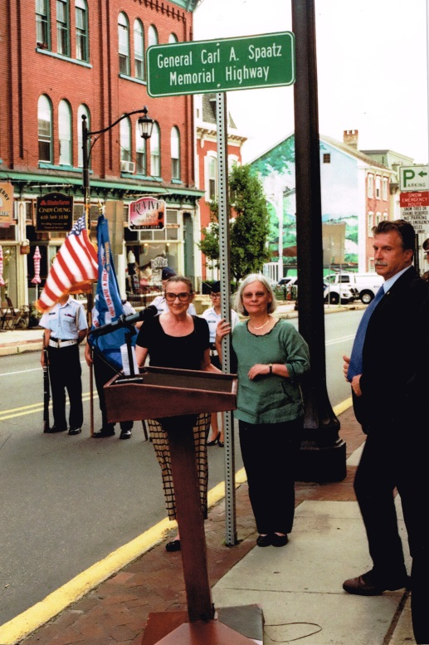

The portion of PA route 562 which runs through Boyertown was renamed the General Carl A. Spaatz Memorial Highway in June 2018. The initiative was spearheaded by PA Representative Dave Maloney and was attended by two of General Spaatz granddaughters.

