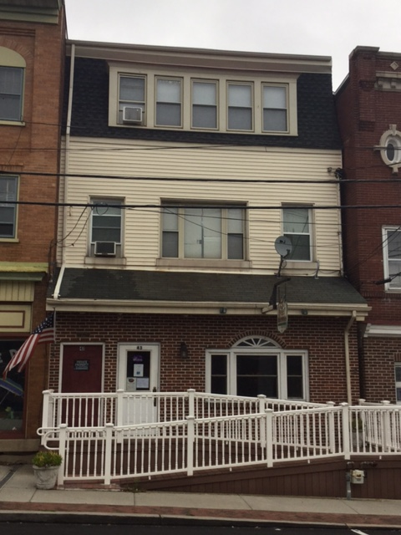
Spatz childhood home Main St Boyertown.
Spatz lived in this house on Main Street in Boyertown until he went away to West Point. Here he helped his parents run the family newspaper the “Boyertown Demokrat”.

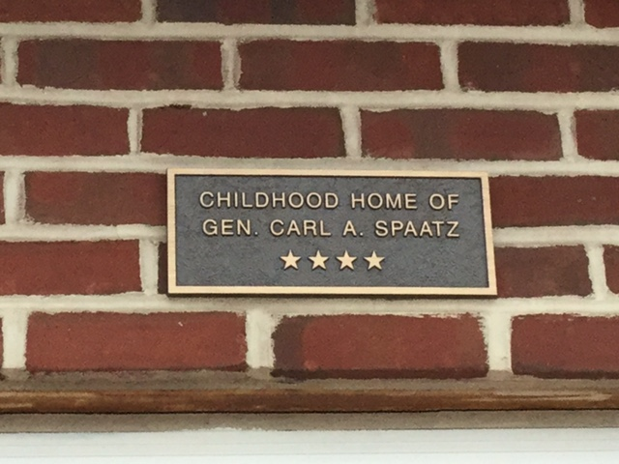

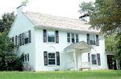
General Spaatz parents Annie and Charles eventually moved to a new house with their 3 remaining children. Carl Spaatz never lived in this new house nicknamed “The Knoll” but he did return to visit.

